Name: Class:

Task 1
1. (a) Three types of computer code are given in the table below. For each type of code, state whether it is high-level language code, assembly code or machine code.
Code | Type of code
INPUT Counter
FOR i Counter TO 0 STEP -1 DO
Counter Counter -1
NEXT i
0000001110000101
0000001110000110
0000000000100110
0000000000011011
0000000000100110
0000000001010001
0000000000000000
0000000000000001

INP
loop OUT
STA count
SUB one
STA count
BRP loop
HLP
one DAT 1
count DAT

(b) A very common computer architecture and instruction set is the 8086 instruction set. Although it was developed for an Intel processor in 1978, it is the basis of the x86 CPU architecture which current Intel processors are based on.
Search for the ‘8086 instruction set’ or the ‘x86 instruction set’. Find at least three instructions that are available in the instruction set and explain what they do. One instruction has been given as an example.
Some websites that may help with researching the 8086 instruction set include:
- https://jbwyatt.com/253/emu/8086_instruction_set.html
- https://en.wikipedia.org/wiki/X86_instruction_listings
- https://onlinelibrary.wiley.com/doi/pdf/10.1002/0471733520.app8
Instruction | Explanation | Example
ADD REG, memory | Adds a memory location to the current value in a register. | ADD AL, 3  This instruction adds 3 to the current value of AL. This is the equivalent of:  AL AL + 3

Task 2
1. Below are three devices that use embedded systems. Complete the table below the pictures and state how these devices use embedded systems.
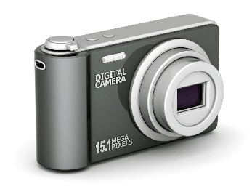
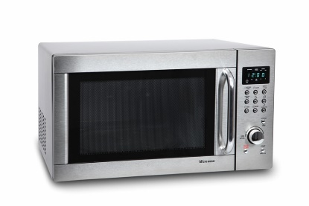

2. Research other embedded systems that are used today.
(a) List as many as you can below.

(b) Select one of the embedded systems you gave in part (a). Research the system then describe the function of the device along with any inputs, outputs, processing and storage required.

